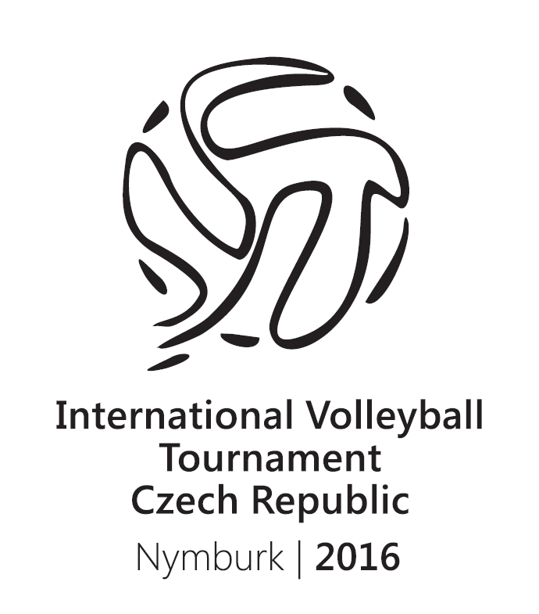
Instructions
International Volleyball Tournament
Nymburk 2016
Director: plk. Ing. Petr Chalupník
Secretary: mjr. Bc. Zdeněk Vlasák
Organiser: ČHSF, HZS Středočeského kraje, SK HZS Středočeského kraje
Date: 11. 4. 2016 až 13. 4. 2016
Place: Sportovní centrum Nymburk, Sportovní 1801, 288 35 Nymburk, tel: +420 325 517 802, GSM: +420 737 224 396 www.scnb.cz
Game system: It will be set at the beginning of the tournament.
Schedule:
11. 4. 2016
12:30 Meeting of the organising group in Nymburk.
13:00 - 15:00 Arrival, accomodation
15:00 - 20:00 Warm up, practice – basketball hall, two courts available, each team maximum 1, 5 h
16:00 - 19:30 Whirpool procedure cca 20 min, book at arrival
17:00 - 19:00 Dinner

12. 4. 2016
08:30 - 09:00 Opening ceremony of the International Volleyball Tournament, presentation of referees and players
09:00 - 11:00 Games in groups 2 won sets
11:00 - 12:30 Lunch (all together) – gym is occupied by basketball players
12:30 - 14:00 Games in groups 2 won sets
14:00 - 15:30 Games in groups 2 won sets
15:30 - 17:00 Ladies Game – Czech national firemen team vs Czech Police national team 2 won sets
17:00 - 18:30 Games in groups 2 won sets
19:00 - 21:00 Whirpool (it is necessary to book your place)
19:00 - 21:00 Sauna (no booking required)
19:00 - 24:00 Dinner

13. 4. 2016
07:30 - 09:00 Breakfast
09:00 - 11:00 Games in groups 2 won sets
11:00 - 13:00 Third place game + ladies game 3 won sets
13:00 - 15:00 Finals 3 won sets
12:00 - 13:30 Lunch
15:00 - 15:30 Closing ceremony, prize giving

Schedule may vary. It depends on the lenght of games.
Gym: 11. 4. 2016 from 15:00 to 20:00 central hall
12. 4. 2016 from 08:30 to 20:00 central hall
13. 4. 2016 from 09:00 to 15:30 central hall

Participants: Men – national firemen team from Belorussia, Latvia, and Slovakia, Czech national firemen team reprezentace and Czech national police team
Women - Czech national firemen team and Czech national police team

Referee: Given by organiser – referee from Czech Volleyball Union
Balls: Given by organiser – SC Nymburk
Technical security: Given by organiser from HZS
Medical care: Given by organiser medical care from HZS
Accomodation: Double and triple rooms
Catering: Lunch or dinner in self-service canteen, you can choose from 2 soups, 3 main dishes, salat bar, warm vegetable, desert, fruit, pastery, drink

Information: mjr. Bc. Zdeněk Vlasák - tel: 950 865 128; 602 680 994
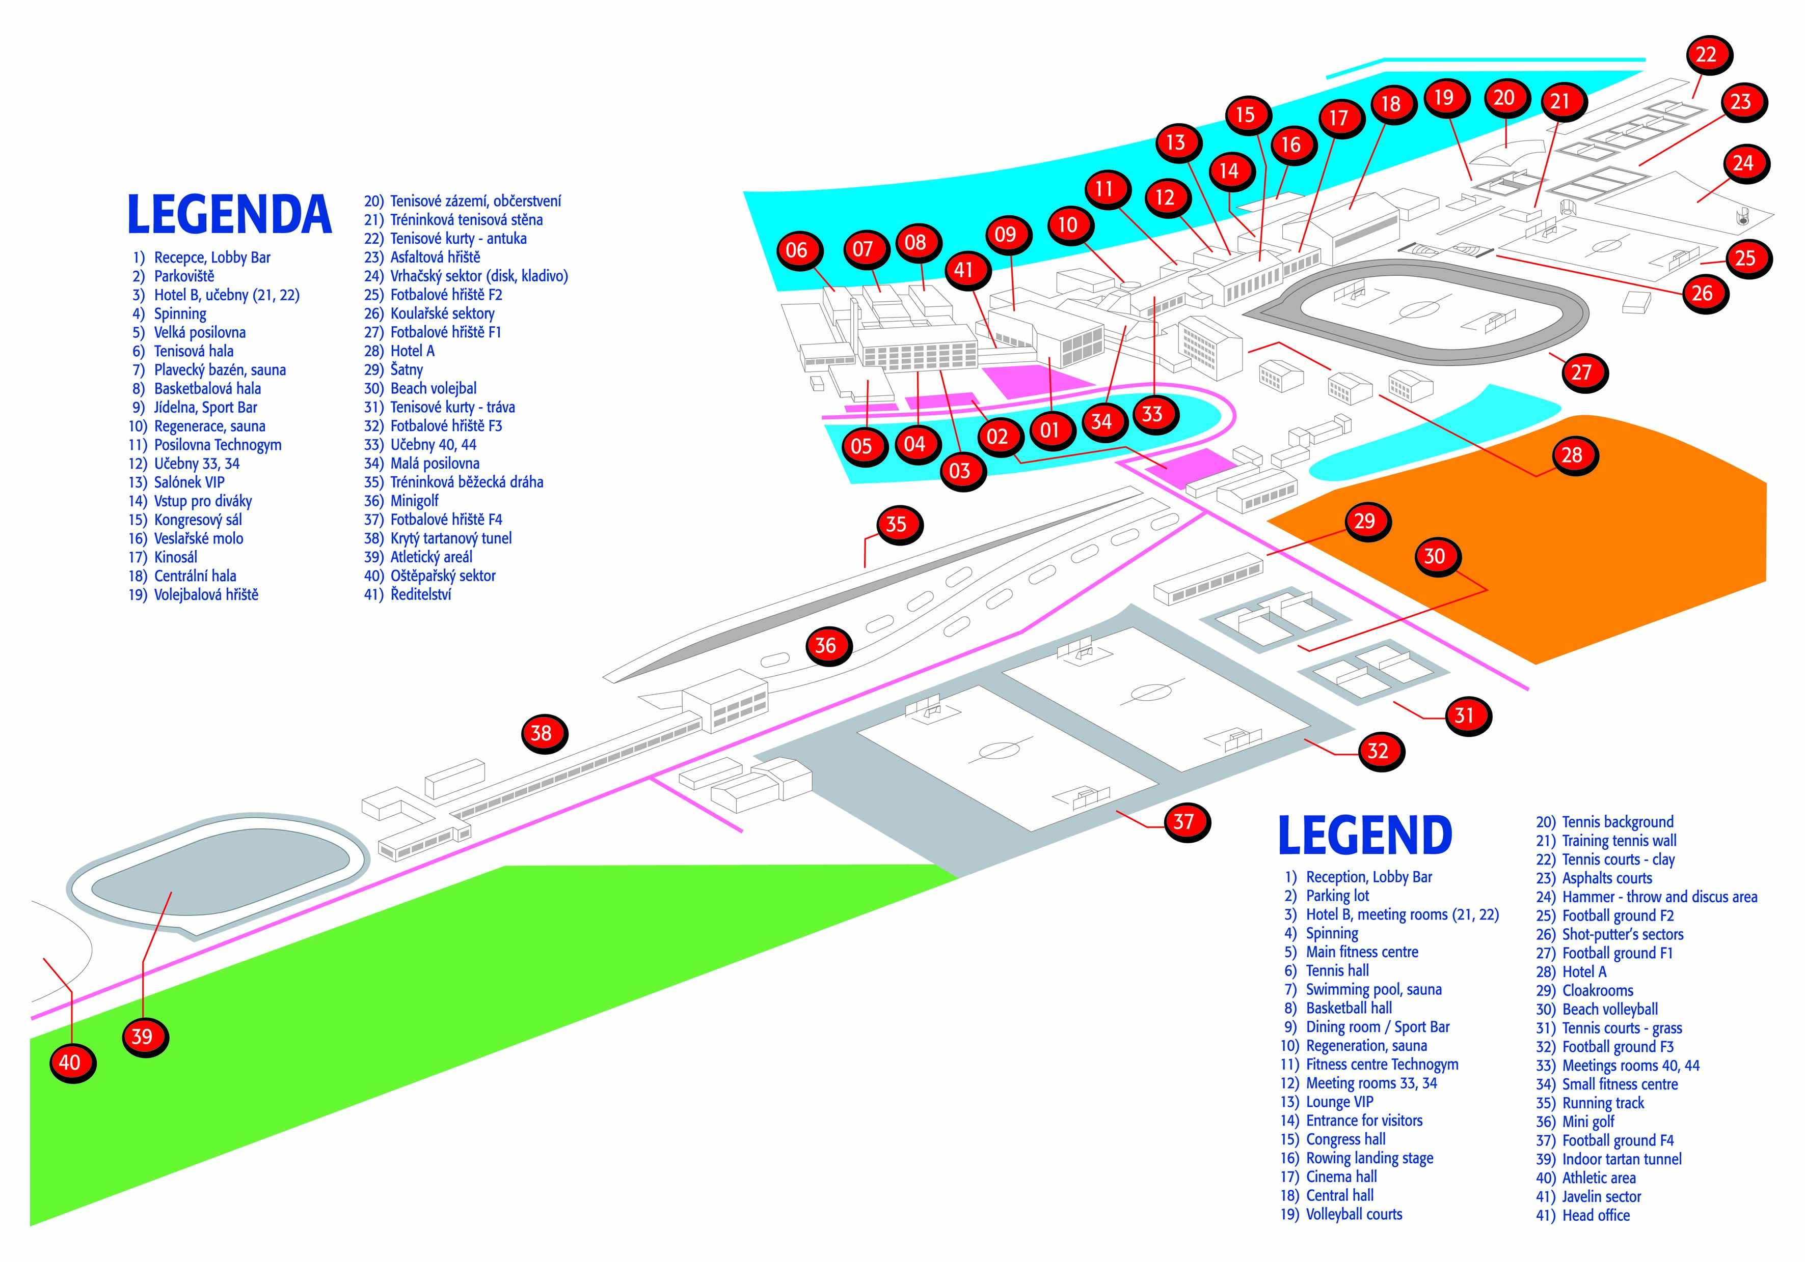
Contact person: mjr. Bc. Zdeněk Vlasák
Email: zdenek.vlasak@sck.izscr.cz
Tel.: +420 602 680 994

